**Kafka Documentation by** [**Smit Joshi**](https://www.linkedin.com/in/smit-joshi814/)

**Create the Kafka user**

* sudo adduser kafka

**Add Kafka User to sudo group**

* sudo adduser kafka sudo

**login to kafka account**

* su -l kafka

**Install JDK if not exists**

* sudo apt update
* sudo apt install openjdk-17-jdk

**Download kafka**

* mkdir ~/downloads
* cd ~/downloads
* wget https://archive.apache.org/dist/kafka/3.4.0/kafka_2.12-3.4.0.tgz

**Download offset exproler and install it**

* https://www.kafkatool.com/download.html

**Extract kafka**

* cd ~
* tar -xvzf ~/downloads/kafka_2.12-3.4.0.tgz

**Rename directory kafka_2.12-3.4.0.tgz to kafka**

* mv kafka_2.12-3.4.0/ kafka/

**Install Vim if you don’t have**

* sudo apt install vim

**Configure Kafka Server**

* vim ~/kafka/config/server.properties
* change the value of **num.partition** to **3**

**Start the Zookeeper**

* ~/bin/zookeeper-server-start.sh ~/kafka/config/zookeeper.properties

**Start Kafka**

* ~/kafka/bin/kafka-server-start.sh ~/kafka/config/server.properties

**Create the Service files so that we don’t have to write the path every time we wan’t sto start the kafka and the zookeeper.**

* sudo vim /etc/systemd/system/zookeeper.service
* and drop the following content there.

[Unit]

Description=Apache Zookeeper Service

Requires=network.target

After=network.target

[Service]

Type=simple

User=kafka

ExecStart=/home/kafka/kafka/bin/zookeeper-server-start.sh /home/kafka/kafka/config/zookeeper.properties

ExecStop=/home/kafka/kafka/bin/zookeeper-server-stop.sh

Restart=on-abnormal

[Install]

WantedBy=multi-user.target

**Same way let’s create the unit file for the kafka**

* sudo nano /etc/systemd/system/kafka.service

[Unit]

Description=Apache Kafka Service that requires zookeeper service

Requires=zookeeper.service

After=zookeeper.service

[Service] Type=simple

User=kafka

ExecStart= /home/kafka/kafka/bin/kafka-server-start.sh /home/kafka/kafka/config/server.properties

ExecStop=/home/kafka/kafka/bin/kafka-server-stop.sh

Restart=on-abnormal

[Install]

WantedBy=multi-user.target

**Now you can manage the kafka by executing the following commands**

* sudo systemctl start kafka
* sudo systemctl status kafka
* sudo systemctl stop kafka

**Testing the kafka server**

* nc -vz localhost 9092

**To Check the logs**

* cat ~/kafka/logs/server.log

**Creating Topic**

* ~/kafka/bin/kafka-topics.sh --bootstrap-server localhost:9092 --create --topic firstTopic

**To check available topics**

* ~/kafka/bin/kafka-topics.sh --list --bootstrap-server localhost:9092

**To produce message to the topic**

* ~/kafka/bin/kafka-console-producer.sh --bootstrap-server localhost:9092 --topic firstTopic

**To read the message**

* ~/kafka/bin/kafka-console-consumer.sh --bootstrap-server localhost:9092 --topic firstTopic –from-beginning

**A Simple Kafka Producer Example**

https://github.com/smit-joshi-addon/kafka-producer-example.git

a simple producer which will produce the data and put it int the topic named **customTopic** if there is no topic present it will create one with default configuration. Which will be most likely a topic with single partition, but if you have configured the num.partitions to 3 in the server.properties then it wll create the 3 partitions using the default configurations from the server.properties.

You can also create the configuration class conatining the required information to create the topic on the fly.

**@Bean**

**NewTopic createTopic() {**

**return new NewTopic("customTopic", 3, (short) 1);**

**}**

Here’s the sample class containg the java based configuration

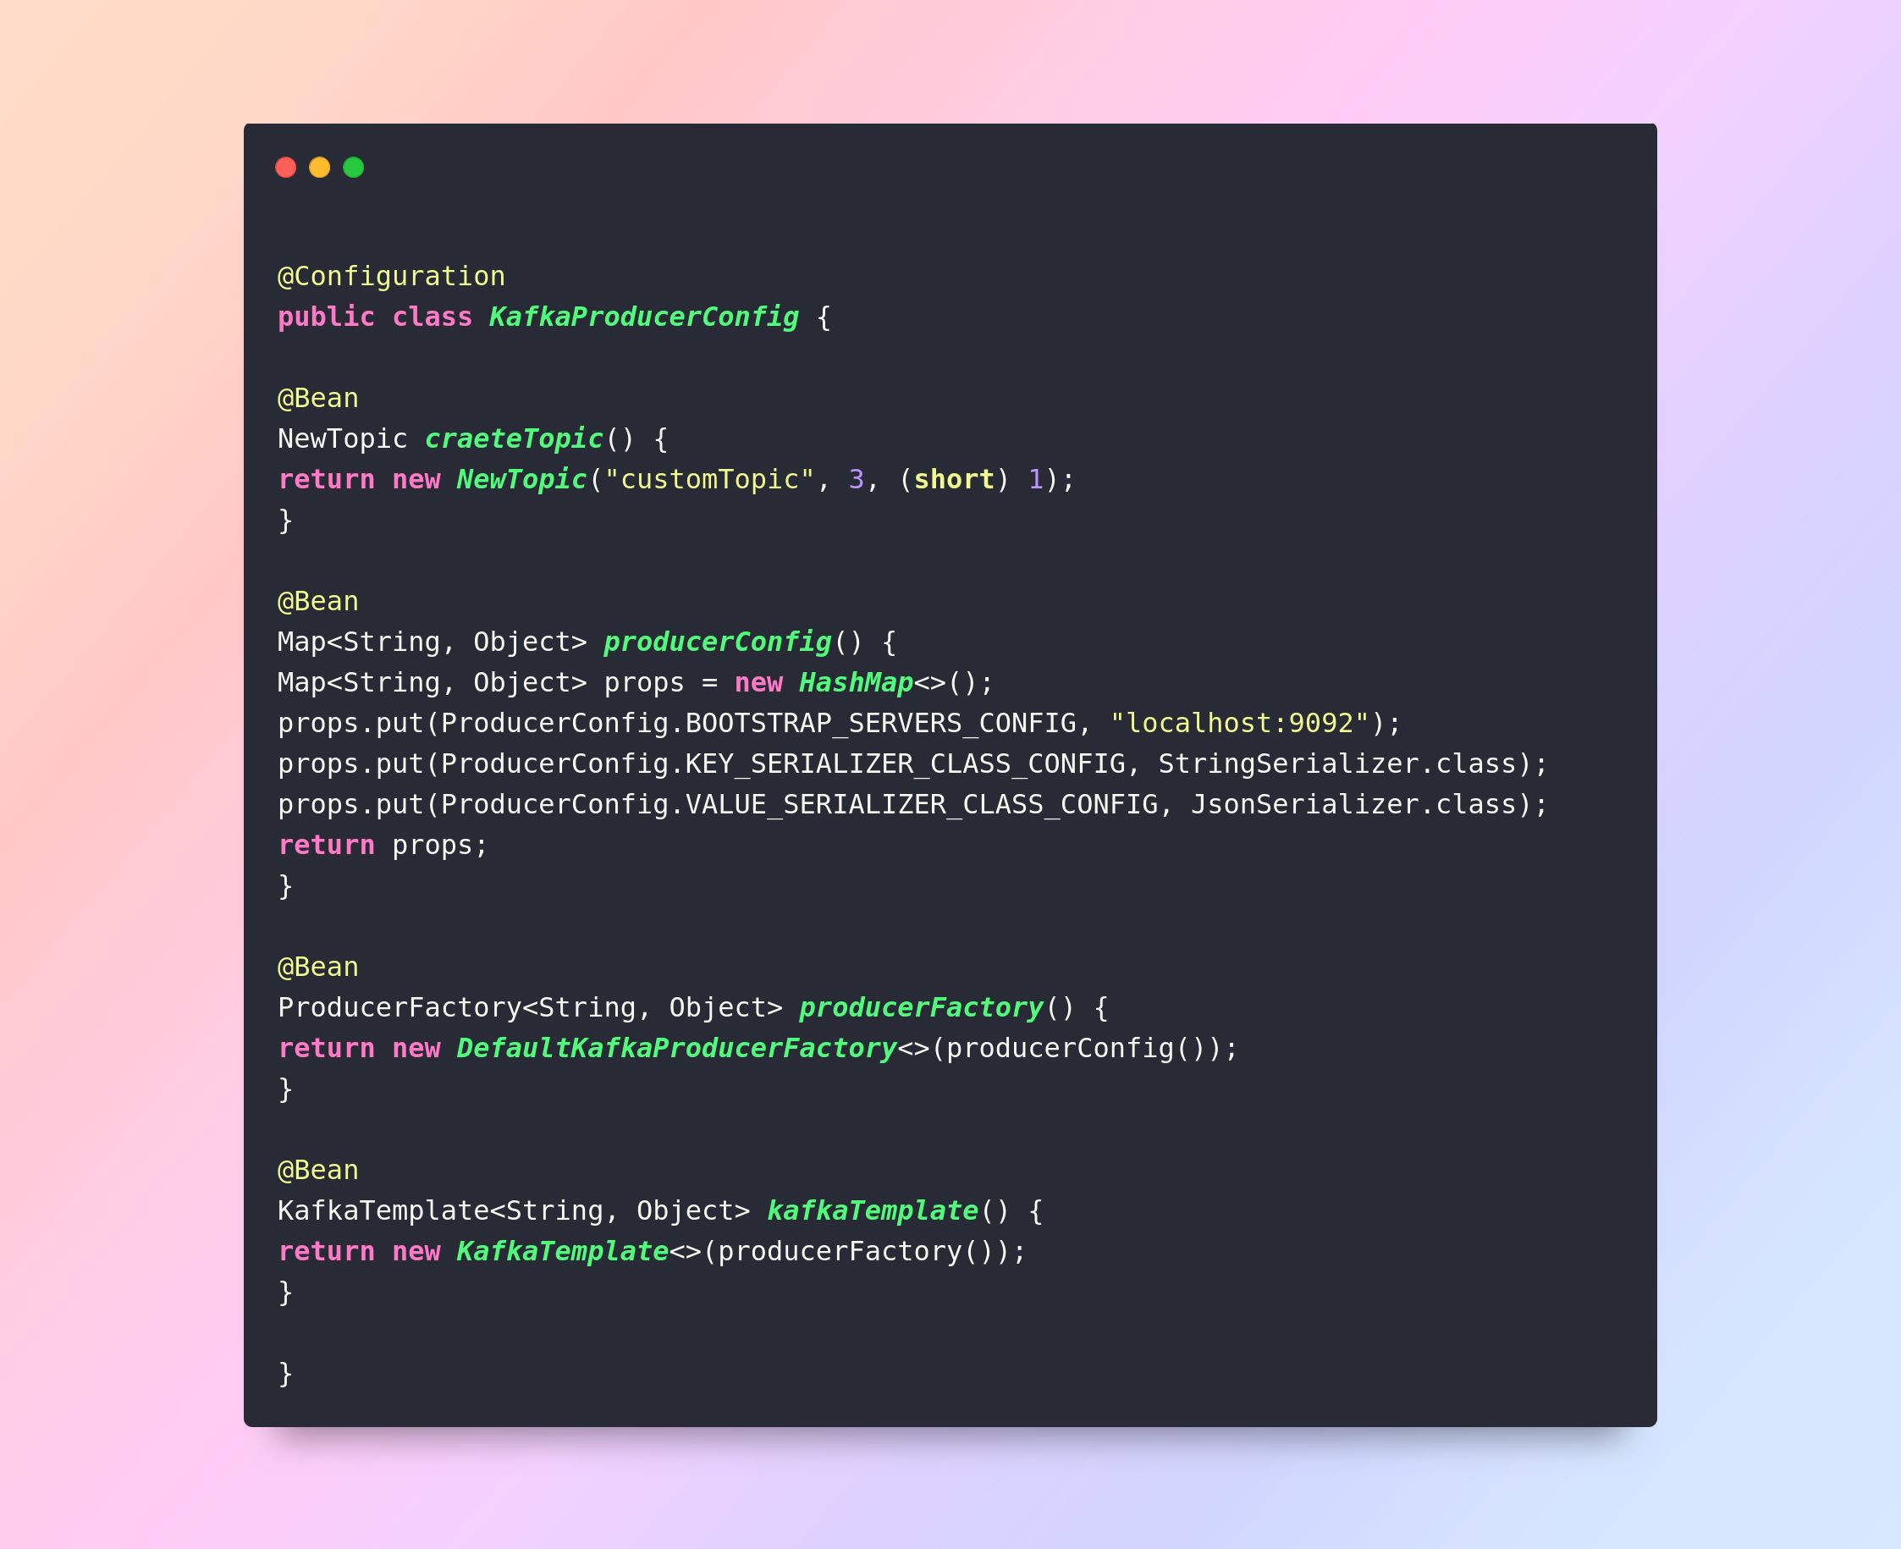

here’s the java based configuration

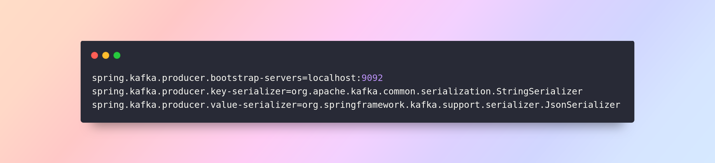

The StringSerializer and JsonSerializer will be used to convert the object to the json when the object is published to the kafka topic.

Here’s the sample class publishing the given String message to the topic.

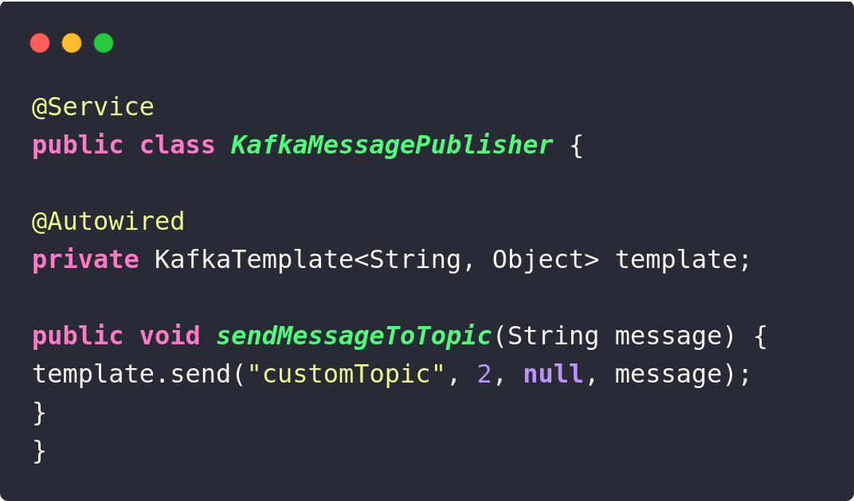

here it will publish the message to the customTopic, again if there is no topic named “customTopic” it will create the topic and then push the message into it.

So how to publish an object ?

To publish a custom object for example Customer object, you’ll have to define the StringSerializer and the JsonSerializer as the key,value serializers in either the properties or tha java based configurations.

Here’s an example demonstarting the usecase.

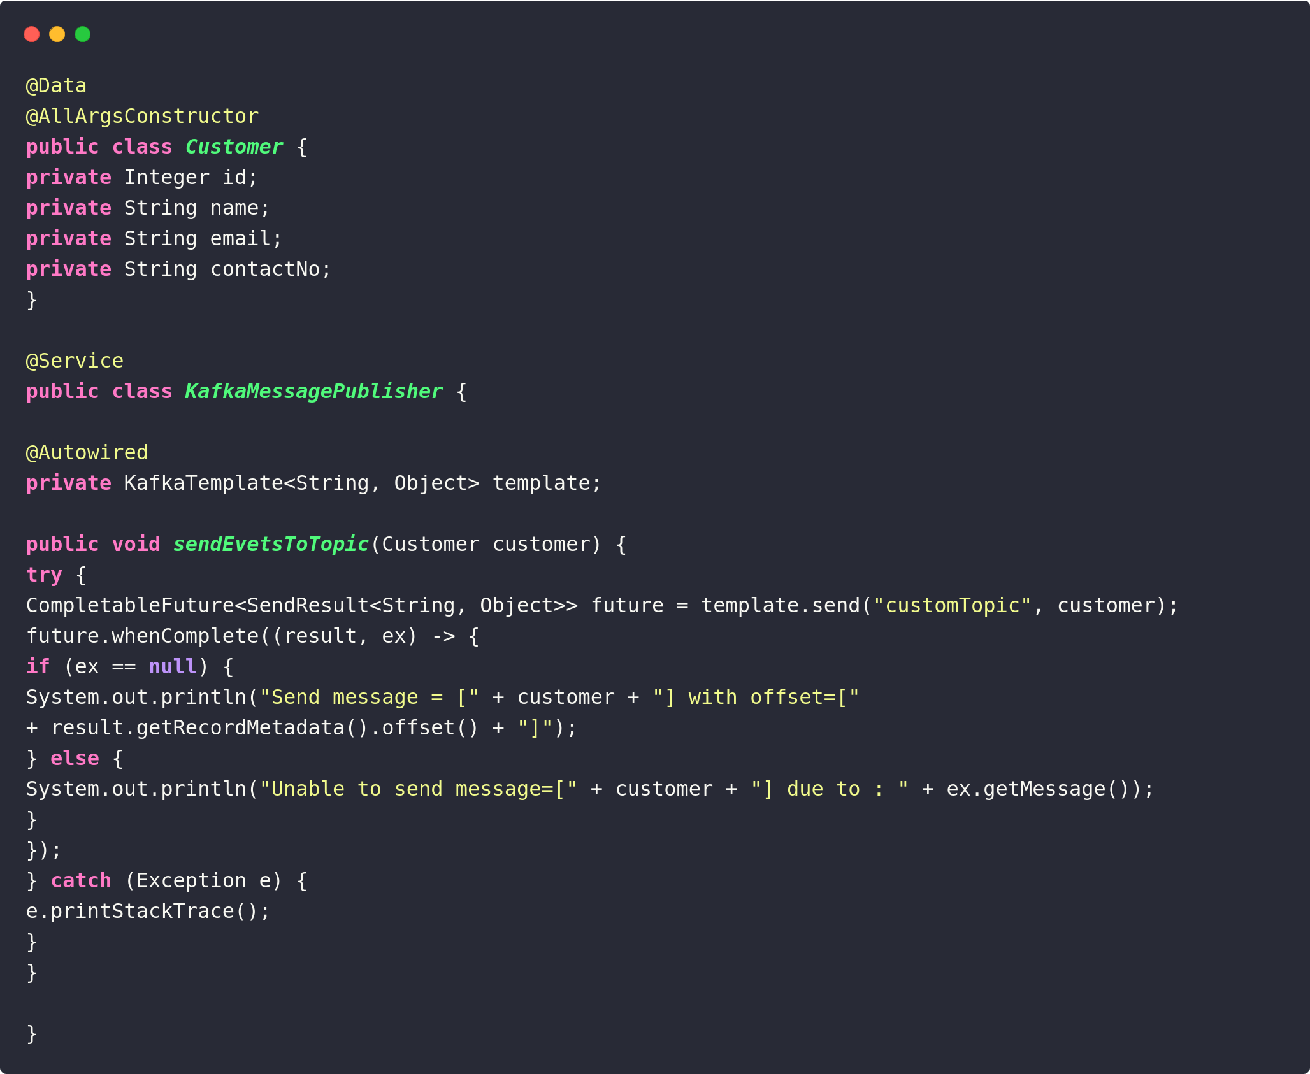

**Consumeing the messages**

checkout the repo https://github.com/smit-joshi-addon/kafka-consumer-example.git

*configs*

Java based config

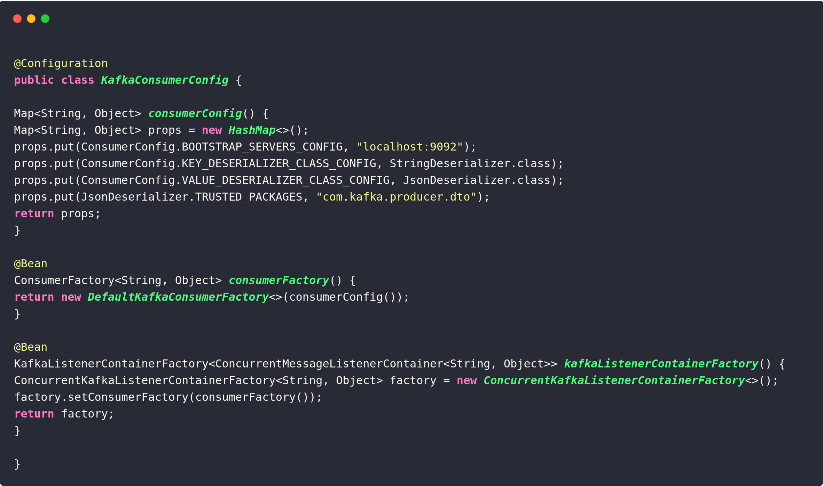

properties based config

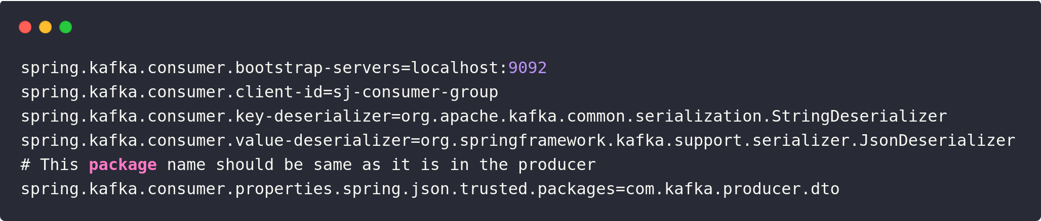

this will listn the simple String message

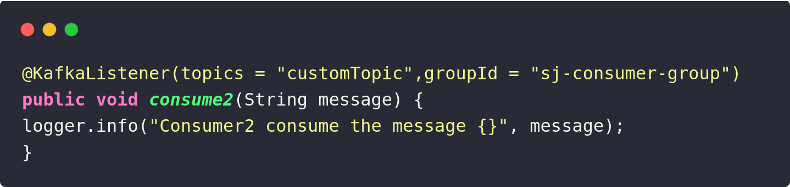

to consume the Objects like Customer you’ll have to add the StringDesirializer and the JsonDeserializer in the configuration.

An example listning the Customer

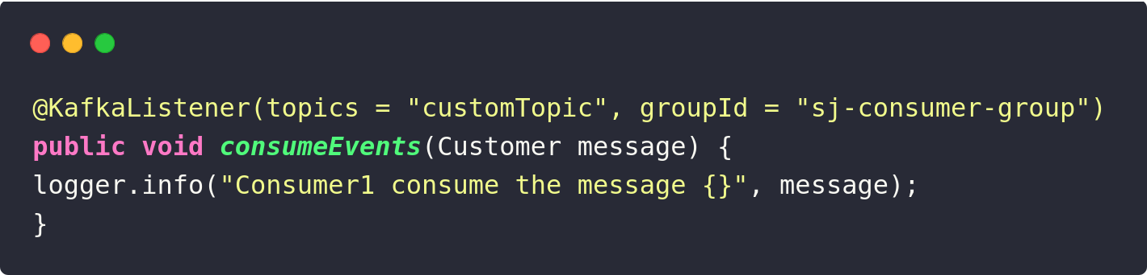

So far so good, let say you received the message but your database is down for some reason so you are unable to save the message / data to your db. Or may be you are unable to send the message from the publisher side, in these senarios we can use the @RetrayableTopic and retry again either continuasly or within some time intervals.

Here’s the dedicated repo to get started : https://github.com/smit-joshi-addon/kafka-error-handling-example.git

let’s look at a simple example from that.

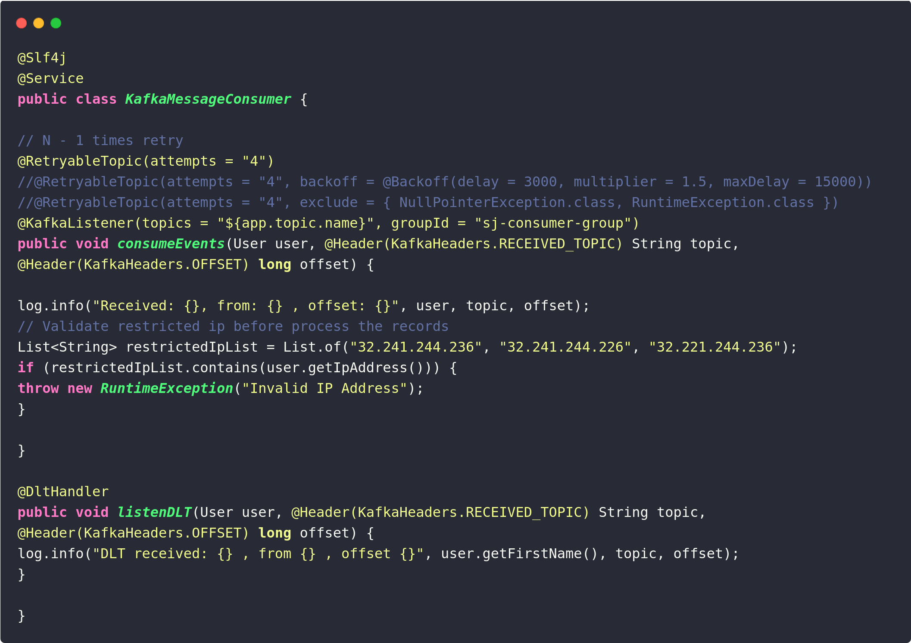

If the attempts in the Retrayable topic is specified to 4 then it will retry 3 times, there are diferent senarious like, if you want to retry continualy then you can just use the attempts but in cases where you would like to wait for some time before retrying then you can set the backoff, and add the delay.

Also if you are wondering what will happen to message if all the attempts are finished and still the conection is not up ?

In that kind of senarious we can create a Dead Latter Topic. (works as name suggests) stores the Messages which are unprocessed, in our case there is a tiny little method with @DltHandler on that, wich will handle these senario if all the attempts are failed then the message will go into the Dead Latter Topics.

Other repo: https://github.com/smit-joshi-addon/kafka-avro-schema-registy.git

This repo contains the avro schema registry demo.

In simple words avro registry is something that will maintain the different version of the schema changes, and will force the consumer & producers to follow the schema. It will also contain the different versions of the schema changes. For example if you have a User entity with (name,email) this is version 1, and let say some change occurs and you add another fields like (age,password,role) this is version 2, or may be you modify the existing fields from name to fullName or username, this will be the version 3.

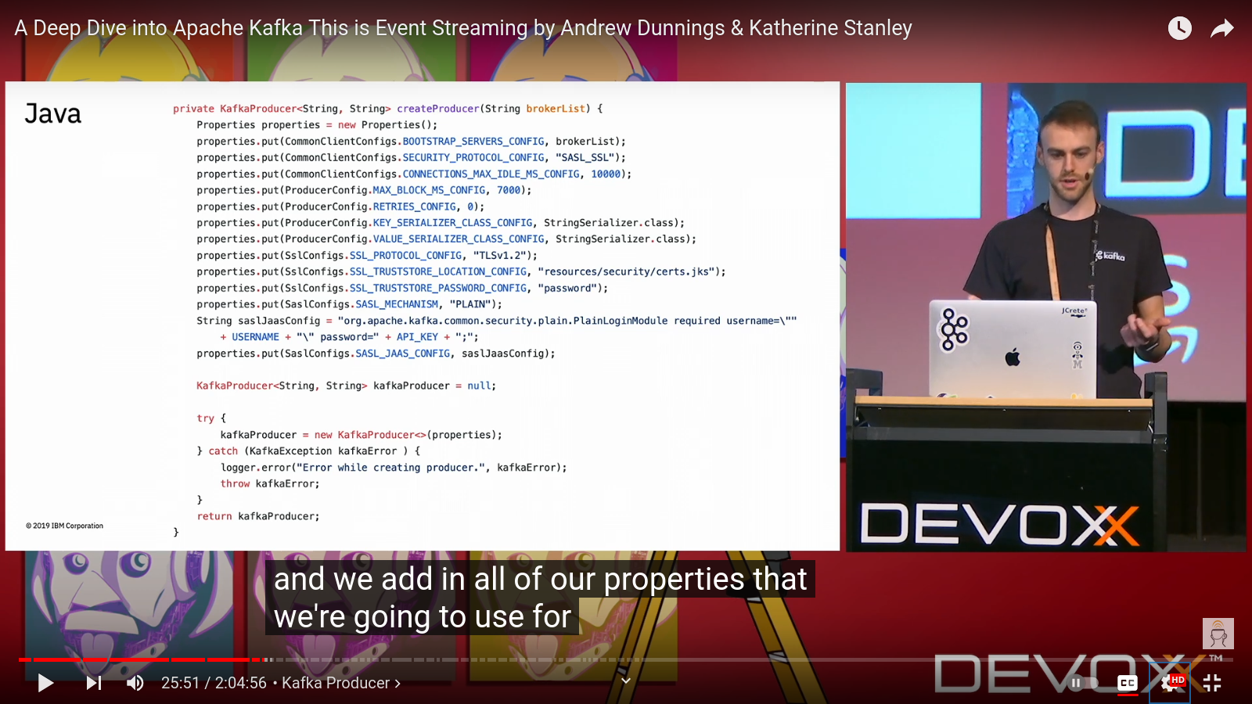pure java based config

spring based config

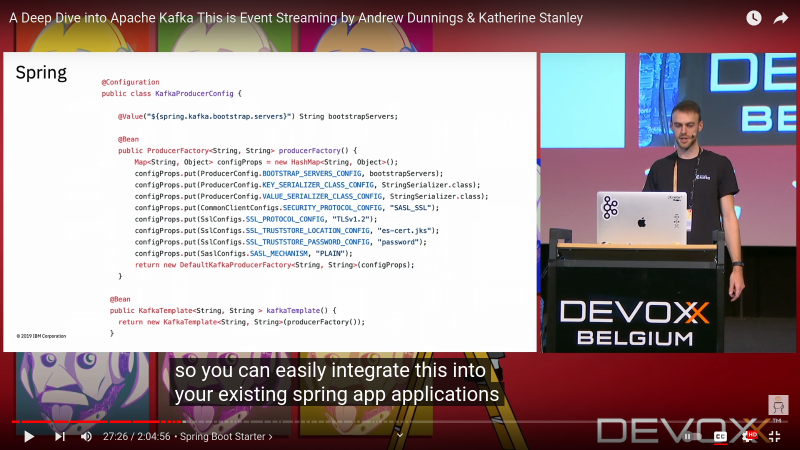

Retention

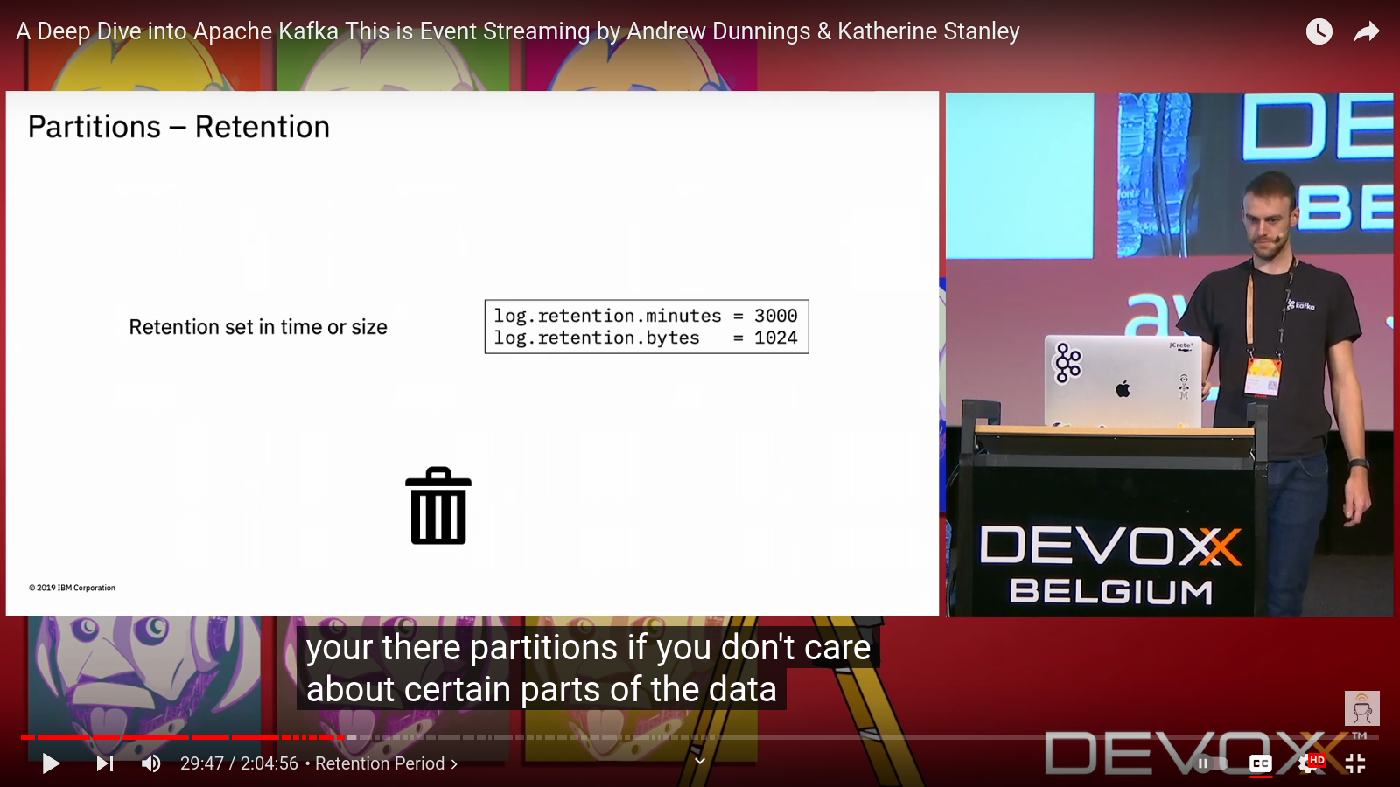

Rebalancing partitions

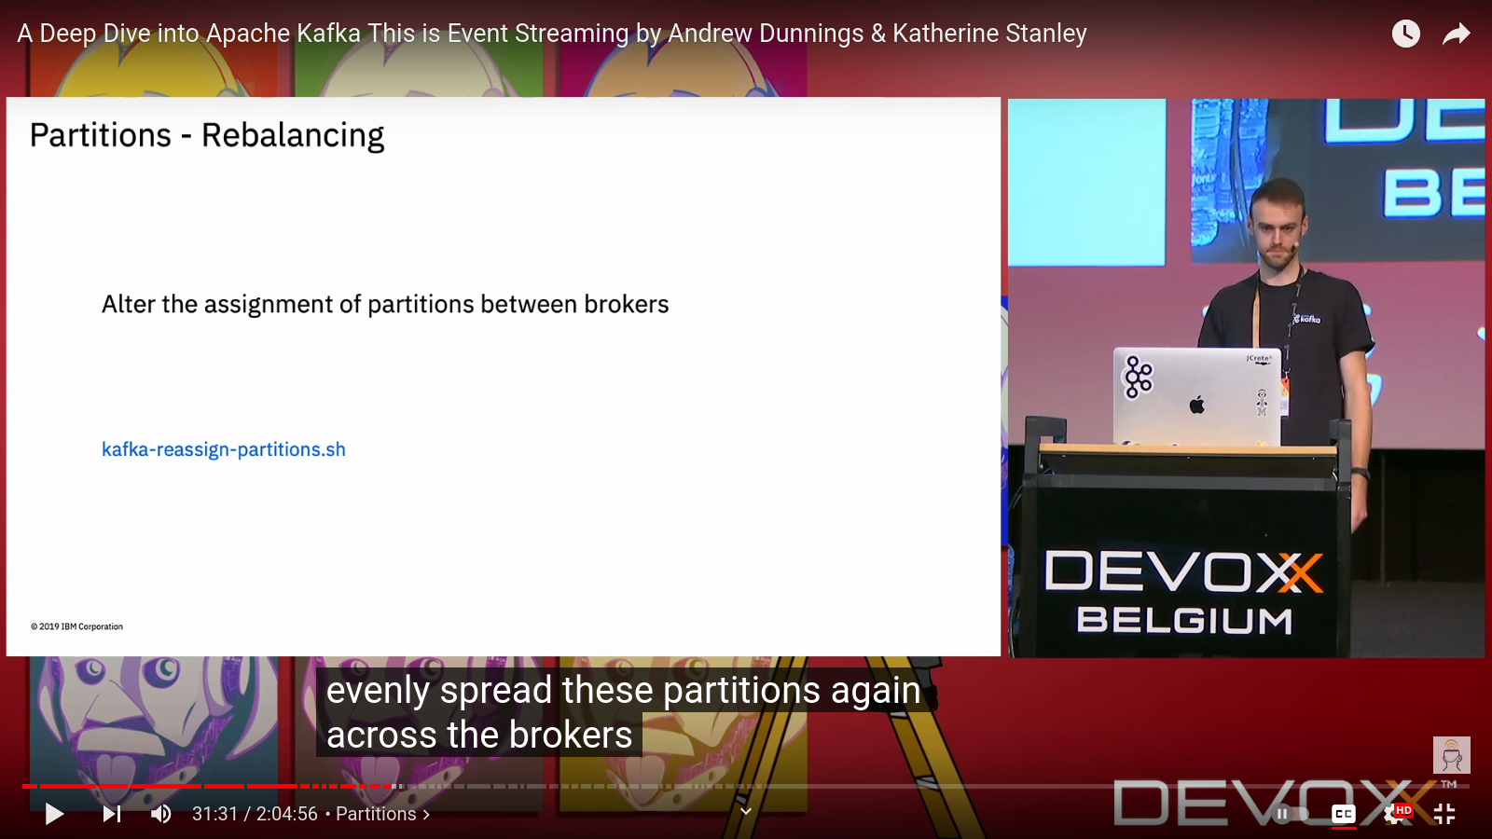

Consumer Config

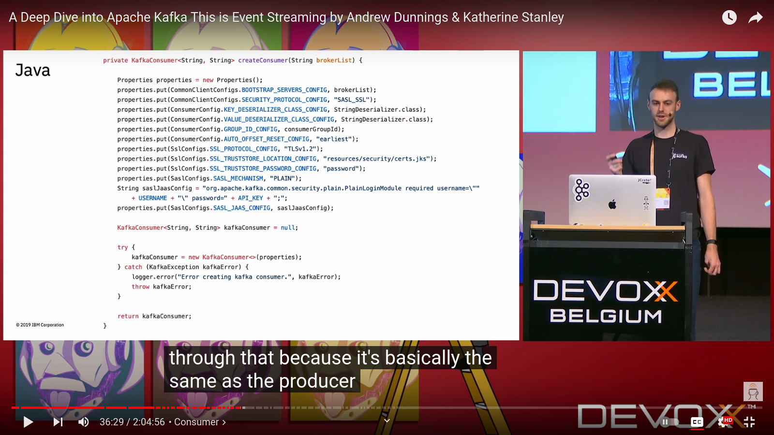

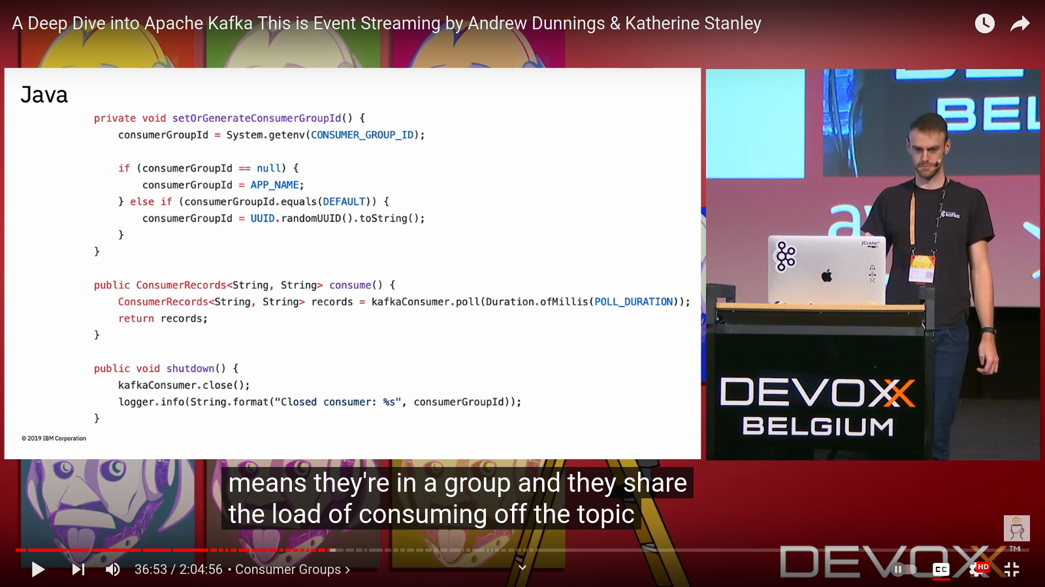

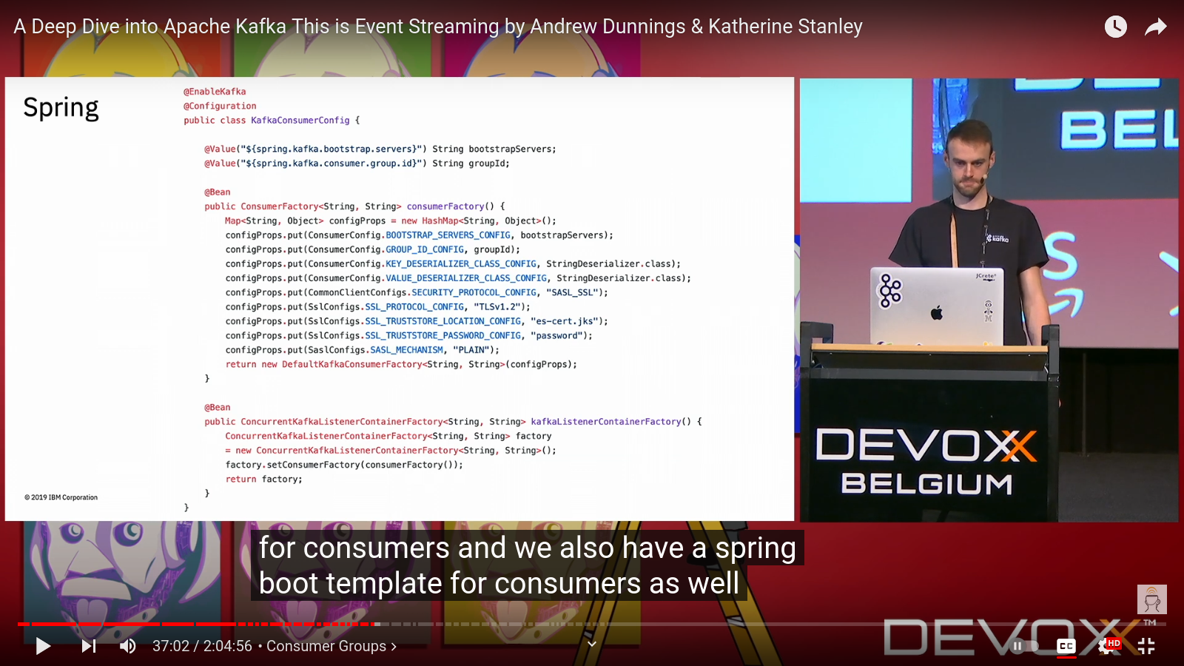

Logging

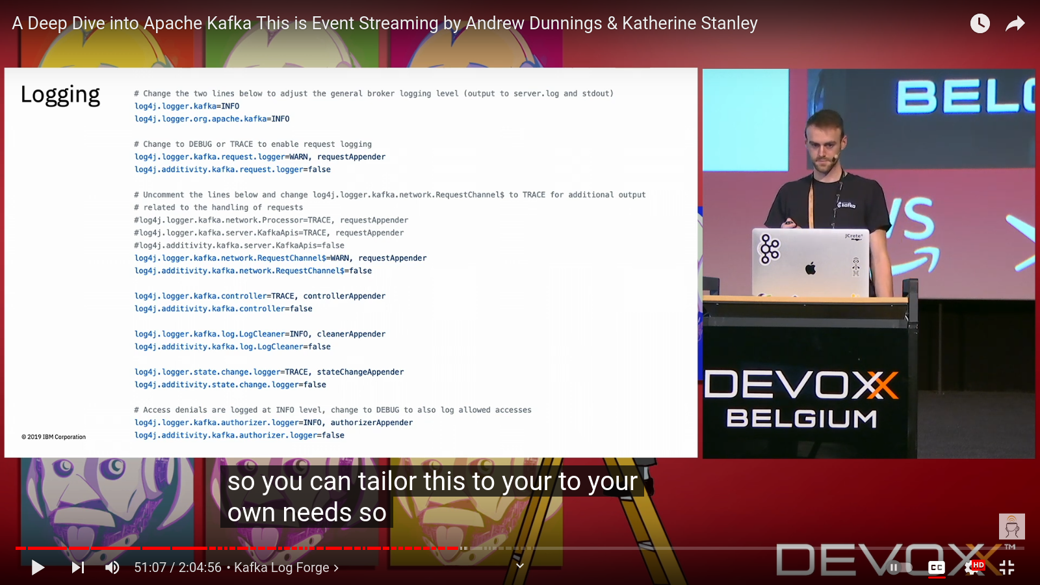

### **High Complexity Use Cases**

1. **PayPal:** Utilizes Kafka for first-party tracking, application health metrics, database synchronization, application log aggregation, batch processing, and risk management, processing over 100 billion messages daily.
2. **New Relic:** Supports real-time monitoring and event processing for mission-critical data at hundreds of gigabytes per second.
3. **Uber:** Integral to their infrastructure for various online and near real-time applications.
4. **Spotify:** Part of their log delivery system and analytics processing.
5. **Zalando:** Acts as an Enterprise Service Bus to transition from a monolithic to a microservices architecture for near-real-time business intelligence.
6. **Nuuly:** Central nervous system for integrating front-end customer experience with real-time inventory management using Kafka Streams and Kafka Connect.
7. **LinkedIn:** Powers activity streams and operational metrics, supporting features like the LinkedIn Newsfeed.

### **Medium Complexity Use Cases**

1. **Rabobank:** Powers financial processes with a digital nervous system using Kafka Streams for real-time alerts.
2. **Oracle:** Provides native connectivity to Kafka for implementing data pipelines via its Enterprise Service Bus.
3. **Optimove:** Uses Confluent Cloud and Kafka to maintain customer data views and support machine learning for campaign effectiveness.
4. **Nussknacker:** A low-code tool where Kafka serves as the primary input and output interface for event streaming and decision algorithms.
5. **Sentry:** Main platform for streaming data, handling event ingestion, product search, business intelligence, and machine learning.
6. **VividCortex:** Ingests high-volume timeseries data for MySQL performance management.
7. **Cisco:** Integrates Kafka in their OpenSOC (Security Operations Center) for enhanced security operations.

### **Lower Complexity Use Cases**

1. **Netstratum:** Uses Kafka for streaming data from products to analytics tools, enhancing real-time monitoring and logging.
2. **Trivago:** Implements Kafka for stream processing in Storm and processing application logs.
3. **Wikimedia Foundation:** Utilizes Kafka for event data production and analytics, including cache invalidation and reliable data ingestion into Hadoop.
4. **Yeller:** Processes streams of incoming exception data, implementing rate limiting, throttling, and batching.
5. **Yieldbot:** Handles real-time events and batch loading via Kafka and supports cross-region replication.
6. **Wize Commerce:** Uses Kafka as a distributed queue for search index generation and collecting user-generated data.

### **Specific Use Cases by Companies**

* **Edenlab:** Manages real-time data flow in healthcare systems using Kafka for microservices communication.
* **Cloudflare:** Processes log analytics, collecting hundreds of billions of events daily.
* **ByteDance:** Collects events and logs for model training and real-time analytics.
* **MoEngage:** Powers event streaming services with over 1 million messages per second across multiple Kafka clusters.
* **Atlassian:** Leverages Kafka for real-time notifications and data synchronization.
* **CJ Affiliate:** Processes key events for core products, aiding in real-time analytics.

### **Summary of Companies and Use Cases**

1. **PayPal:** Tracking, metrics, synchronization, and analytics at scale.
2. **New Relic:** Real-time monitoring and event processing.
3. **Uber:** Supports various real-time applications.
4. **Spotify:** Log delivery and analytics.
5. **Zalando:** Enterprise Service Bus for microservices transition.
6. **Nuuly:** Customer experience and inventory management integration.
7. **Rabobank:** Real-time financial alerts.
8. **Oracle:** Data pipeline implementation.
9. **Optimove:** Customer data views and campaign support.
10. **Nussknacker:** Event streaming and decision-making interface.
11. **Sentry:** Streaming data and business intelligence.
12. **VividCortex:** Timeseries data management.
13. **Netstratum:** Real-time data streaming.
14. **Trivago:** Stream processing and log management.
15. **Wikimedia Foundation:** Event data and analytics.
16. **Yeller:** Exception data processing.
17. **Yieldbot:** Real-time events and batch loading.
18. **Wize Commerce:** Search index generation and user data collection.
19. **Cloudflare:** Log analytics and data collection.
20. **ByteDance:** Event and log collection for analytics.
21. **MoEngage:** Event streaming at scale.
22. **Atlassian:** Notifications and synchronization.

# **Real-world use cases and examples of Kafka implementations**

**[Open](https://medium.com/@psnavya90/real-world-use-cases-and-examples-of-kafka-implementations-37eade7762c5" \l ":~:text=Example%3A Smart cities leverage Kafka,monitoring%2C and optimizing city services.)**

**Kafka In Action**

[Open](https://livebook.manning.com/book/kafka-in-action/chapter-1/2)